MA40198 Coursework

**Model Checking**

First, we verify that each parameter estimate is significant, i.e., different than zero. To determine this significance, we compute the 95% Credible Intervals (CI’s) and check whether these intervals contain zero or not.

* 95% CI for E0: 1.437- 9.079
* 95% CI for Emax: 109.695-120.766
* 95% CI for ED50: 71.780-82.997
* 95% CI for λ: 2.833-2.998
* 95% CI for σ2: 3.533-3.823
* 95% CI for β: 6.505-16.018

Thus, we can conclude that each parameter is significantly different than zero. In particular, the parameter β, which is associated with a different response to the treatment in presence of the biomarker is different than zero. So we can also add to our conclusions that the presence of the biomarker affects the effectivity of the treatment.

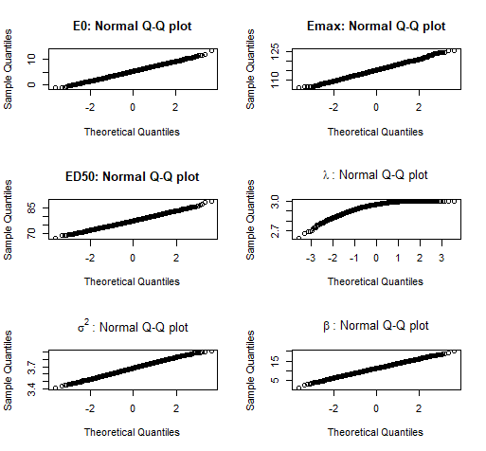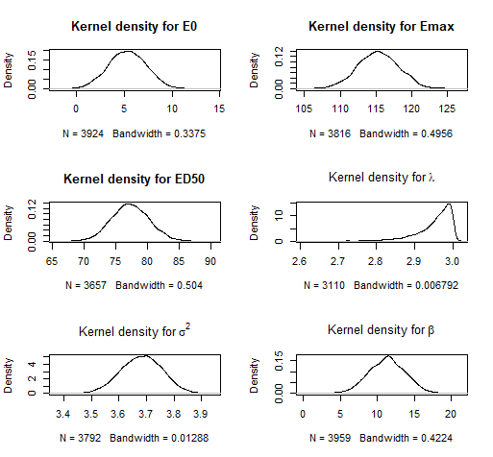

Using the estimated parameter values, we calculate the predicted response to treatment and the residuals as the difference between the predicted and the observed response. We can confirm that the presence of the biomarker provides a significant difference in the response to treatment.

To assess if the model is proving a significant fit, we compute the residuals between the predicted and the observed responses to the treatment. From these plots we can observe that the residuals show no discernible pattern, providing evidence of them having constant variance. Further, we can see from the autocorrelation plot that there is no correlation between them. Finally, the normal quantile plot shows a linear trend, proving visual evidence that they are normally distributed, this was later confirmed by performing the Cramer-von Mises normality test. This allows us to conclude that the residuals come from a normal distribution and are uncorrelated, hence they are independent.

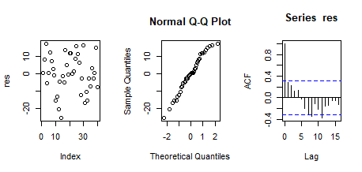

<http://www.math.chalmers.se/~rootzen/finrisk/reportwriting0315.pdf> : for how to write a report

<https://www.wikihow.com/Write-a-Statistical-Report>

<http://file.zums.ac.ir/ebook/75-Dose%20Finding%20in%20Drug%20Development%20(Statistics%20for%20Biology%20and%20Health)-Naitee%20Ting-0387290745-Sp.pdf>